Final Project

Design Philosophy

Josh Lane

Introduction to HCI Theory

April 2, 2018

SP 18-IN-INFO-I275-24955

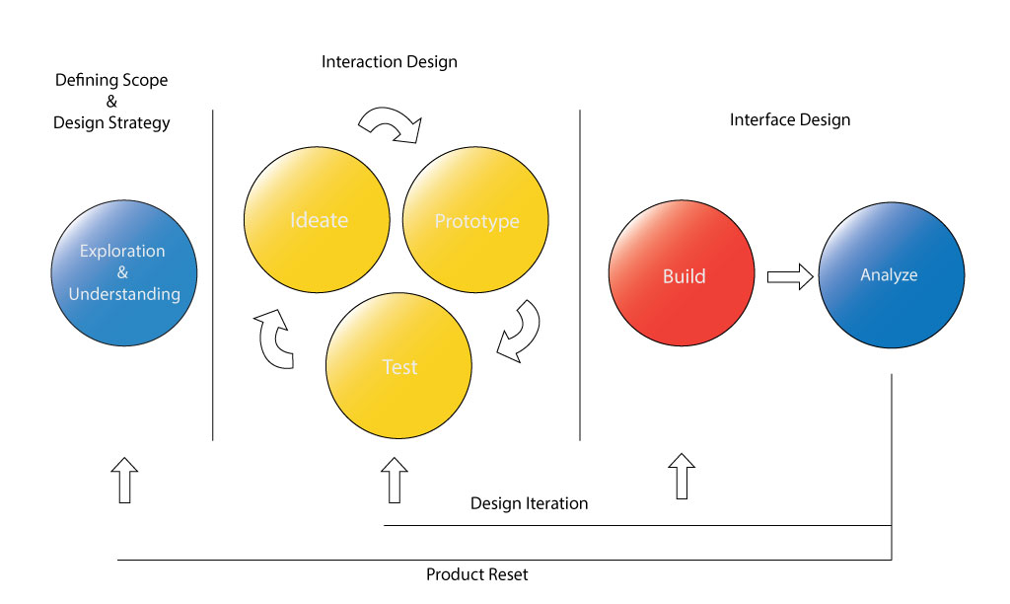

***Defining Scope and Design Strategy***

When I start a new design project, my first objective is exploring and understanding the context or the problem space for which I am designing. This involves investigating and researching my problem space to the point where I feel I have enough knowledge of my problem space to later begin brainstorming design ideas. This allows me to scope out the resources and the timeframe in which the design will require to be done well enough to hold promising results. This also allows me to begin looking into the types of data I want to collect when testing my designs later on so I can begin thinking of not only how I want the design to look, but how I will test and compare my designs to find the right design for every project.

***Interaction Design***

After the scope and design strategy for the project have been clearly established, at this point in the project I would typically begin brainstorming or listing out as many ideas as possible. From those initial ideas I begin narrowing ideas based on what are most promising for that design. This is part of the ideation, or creative process, phase in my design process where it is important to get as many ideas and sketches down as possible in order to exhaust all possible solutions to compare and contrast designs to come up with variants to create the best design. Once settled on sketches begin to be finalized and polished low-fidelity prototypes are built and tested with users. Based on their feedback designs are modified as necessary and high-fidelity prototypes are built and tested again. At this point I would conduct any tests to obtain data to solidify a design with statistics e.g. heuristics, A/B testing, etc. The tools used to obtain data vary for every design and there is not one tool fixes all solution and finding the right combination of tools to obtain data from a design is important to maximize usability within a design.

***Interface Design***

When a design has made it to final cuts it is then time to build out your design and critically analyze the design and test how the target audience responds to the design. If the design is acceptable this is the end of the design process and you would move on to the next project and start the process over again, however if the design is not up to par with expectations of the project, then I would meet with stakeholders in the project and decide if the project is worth investigating other interactive designs or is it best to pivot and move on to an entirely new project or design direction.

***Core Tenets of my Design Philosophy***

**What works in theory, doesn’t necessarily work in application.**

**Source:**

Karafillis, Anastasios. “When You Shouldn't Use Fitts Law To Measure User Experience.” *Smashing Magazine*, 4 Dec. 2012, [www.smashingmagazine.com/2012/12/fittss-law-and-user-experience/](http://www.smashingmagazine.com/2012/12/fittss-law-and-user-experience/)

It is important to understand when theories are and aren’t applicable within the context of your design space. Not every theory work well in application and not every theory works for every problem understanding the lessons and warnings behind each theory can help a designer feel confident about their design choices. That said poor understanding and application of a theory can hurt the design just as easily. Fitts Law informs designers that the larger their clickable links and buttons are the more usable they will be but it is also a warning that making these links and buttons unnecessarily large will lose real-estate on your user interface that won’t gain you much in terms of being easier or more usable to the user. Karafillis gives us an example of when and why radial menus fail practice. Karafillis mentions that they are not easily expanded since they already take up so much space and they quickly become disorganized with growth.

I have seen radial menus in VR games that were done successfully simply because it was a 3d painting app and it acted as a panel to select colors and different brushes on both hands and was held in a low stress environment where the game didn’t pressure into making hasty decisions. I have also seen it poorly executed in other games where it was trash because there were so many options that were buried in the menus and you had to really understand and know where everything was to quickly select them and build them while under pressure from your opponent. The controls to select the links were also too finicky and you could easily accidently go into a section of the radial menu you didn’t want to go in too. This shows that the theory can be applied correctly but it is all too easy to apply it incorrectly.

**Design inclusively over exclusively.**

**Source:**

Langdon Winner. “Do Artifacts Have Politics?” 1980, <https://www.jstor.org/stable/20024652?seq=1#page_scan_tab_contents>

Winner names an example within his article “Do Artifacts Have Politics?” in which Robert Moses built parkways that were 9 feet tall so he could keep the majority of poor, handicapped, and black individuals away from the beach because the public transport buses were 12 feet tall and could not pass through under the parkways. This allowed only the "upper" and "comfortable middle" class families that owned automobiles to pass under the parkways to cross the bridge to the beach. There were demonstrations and lawsuits as a result against the parkways for limiting parts of the city life to minority groups. I think Winner was trying to say that the designer’s intent doesn't matter necessarily perhaps because not all designs end up working the way that we intended their initial use the parkway case per the article while morally appalling did work as Moses had intended. I think the designs outcome absolutely matters when looking at the intended use of the design. There should always be the question of morality in every action we take as designers and to be as inclusive as the design demands. A design doesn't necessarily need to work for everyone. e.g. you wouldn't design an app for accountants the same way you would design it for everyday people.

**There are no standardized tool sets to design for every problem space.**

**Sources:**

Saul Greenberg, Bill Buxton. “Usability Evaluation Considered Harmful

(Some of the Time)” April 5-10, 2008, <https://dl.acm.org/citation.cfm?id=1357074>

Cockton, Gilbert. “Ingredients and Meals Rather Than Recipes: A Proposal for Research That Does Not Treat Usability Evaluation Methods as Indivisible Wholes.” *International Journal of Human-Computer Interaction*, [www.academia.edu/1963416/Ingredients_and_Meals_Rather_Than_Recipes_A_Proposal_for_Research_That_Does_Not_Treat_Usability_Evaluation_Methods_as_Indivisible_Wholes](http://www.academia.edu/1963416/Ingredients_and_Meals_Rather_Than_Recipes_A_Proposal_for_Research_That_Does_Not_Treat_Usability_Evaluation_Methods_as_Indivisible_Wholes).

It is important to note that there are no one stop shops or fix all solutions found within every problem space to evaluate usability within a design. All projects are unique and should require unique solutions to fix them. It’s also okay to go against the “rules” and test new theories if they are reasonable within the context of your problem space. The Greenberg and Buxton article talks about how usability evaluations could be harmful depending on context of the problem space, the designer's understanding of what output a usability evaluation is used for, and the product they are designing for. Knowing when to use tests is key within every project and performing them because that’s what you were taught or is the "rule" doesn't always yield the best results and can potentially harm the quality or design of the product.

The Ingredients and meals rather than recipes article recommends that designers shouldn't just use tools, e.g. personas, heuristic evaluation, etc., within their usability evaluation's because not ever project require the same tools to be used. Rather the article suggests we as designers should become "chefs" and create new recipes using "ingredients" that are tailored for that project.

**Designers are not users!**

It is important to design to empathize with and design for your target audience. As designers we tend to get into ruts thinking that there are limited solutions in designing within a problem space. We also can get attached to our designs always keep focus and remember you are designing new innovative, useful, interactive designs to improve a process in which a user performs a task.

**Good designs are practical, functional, and are experienced not seen.**

**Sources:**

Cockton, Gilbert. “Ingredients and Meals Rather Than Recipes: A Proposal for Research That Does Not Treat Usability Evaluation Methods as Indivisible Wholes.” *International Journal of Human-Computer Interaction*, [www.academia.edu/1963416/Ingredients_and_Meals_Rather_Than_Recipes_A_Proposal_for_Research_That_Does_Not_Treat_Usability_Evaluation_Methods_as_Indivisible_Wholes](http://www.academia.edu/1963416/Ingredients_and_Meals_Rather_Than_Recipes_A_Proposal_for_Research_That_Does_Not_Treat_Usability_Evaluation_Methods_as_Indivisible_Wholes).

Mark Weiser. “The computer for the 21st century”, 1999, <https://dl.acm.org/citation.cfm?id=329126>

Weiser states in his article “The Computer for the 21st Century”, “The most profound technologies are those that disappear. They weave themselves into the fabric of everyday life

until they are indistinguishable from it.” It’s only when technologies have seamlessly integrated as part of our everyday lives that we as users begin to overlook its flaws and can’t begin to imagine life without them. e.g. cellphones, cars, TV’s, etc. Dalsgaard says that technology is taking on new roles and new forms within our lives and within the ever-evolving sciences that are still appearing, with many of these new theories being widely untested and may not necessarily be pragmatic in the sense of being well tested or working well in actual application. Ultimately, I think encouraging designers to make new useful technology that is both functional and practical.